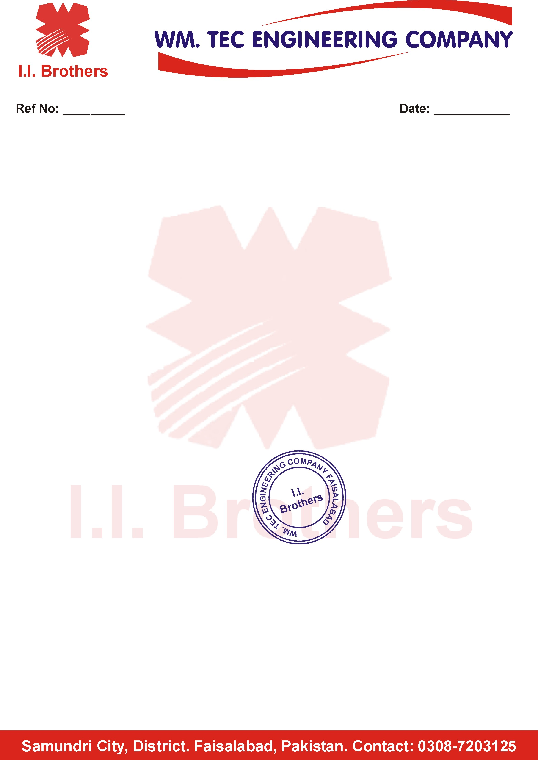

**<To2>**

**TO WHOM IT MAY CONCERN**

This is certified that Mr. <Name> S/O <fname> has worked with our organization at WM Tec Engineering Comapny Faisalabad, as “<Designation>” from <From2> to <To2>.

During this period he has proved himself an honest, dutiful, efficient & hardworking.

We wish him success in his future career.

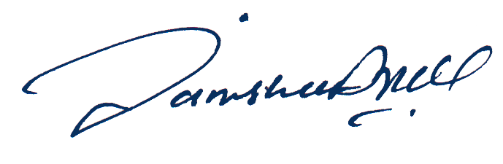

**General Manager**